**NANDHA ENGINEERING COLLEGE**

**(Autonomous Institution)**

Erode-638 052



**TABLEAU - TWO CREDIT COURSE**

**PROJECT TITLE : Indian Disasters Analysis**

**IV – Semester**

**B.Tech - Artificial Intelligence and Data Science**

**NAME : Karthikeyen K**

**BRANCH : B.TECH AI & DS**

**YEAR : II**

**TABLEAU DEFINITION AND USES**

Tableau is a powerful data visualization and business intelligence platform that enables users to create interactive and shareable dashboards. It allows for the exploration, analysis, and presentation of data through intuitive visualizations such as charts, graphs, and maps. Tableau connects to various data sources, including spreadsheets, databases, and cloud services, to transform raw data into actionable insights.

**Uses :**

* Data Visualization : Create dynamic and visually appealing representations of complex datasets.
* Data Analysis : Perform exploratory data analysis to uncover trends, patterns, and outliers.

**PROJECT OVERVIEW**

**Overview:**

The Disaster Data Analysis Project focuses on analyzing a comprehensive dataset of disaster events in India. The dataset contains detailed records of disaster events, including attributes such as disaster type, date, state, severity, population affected, economic loss, infrastructure damage, and more. The project leverages Tableau to visualize and analyze this data to derive meaningful insights into disaster trends, impacts, and response strategies.

**CHART – 1**

**Count of disaster per year**

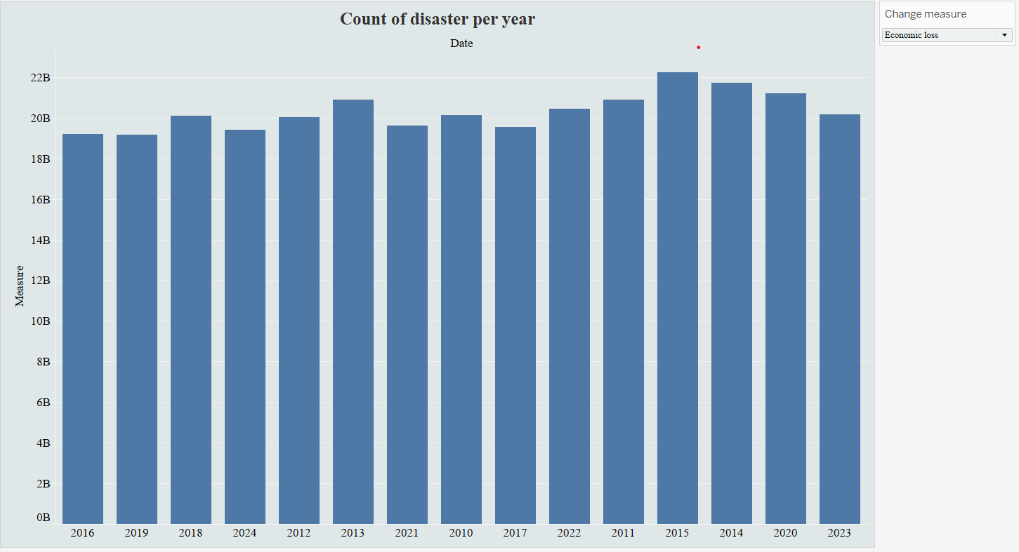

This visualization presents a year-wise analysis of key disaster metrics in India, created using a dynamic parameter control.  
The user can switch between three different measures:

* Disaster Count
* Economic Loss
* Affected People

The chart illustrates a generally increasing trend across the selected metrics over the years, highlighting the rising impact and improved reporting of disasters. Although the data shows a consistent pattern, a minor chronological inconsistency is noted in the year labels, which can be corrected for better clarity. Overall, the visualization provides a comprehensive view of disaster frequency, economic impact, and human affectation, supporting a deeper understanding of disaster trends in India.

**CHART – 2**

**Economic loss affected by frequency of disaster count per state**

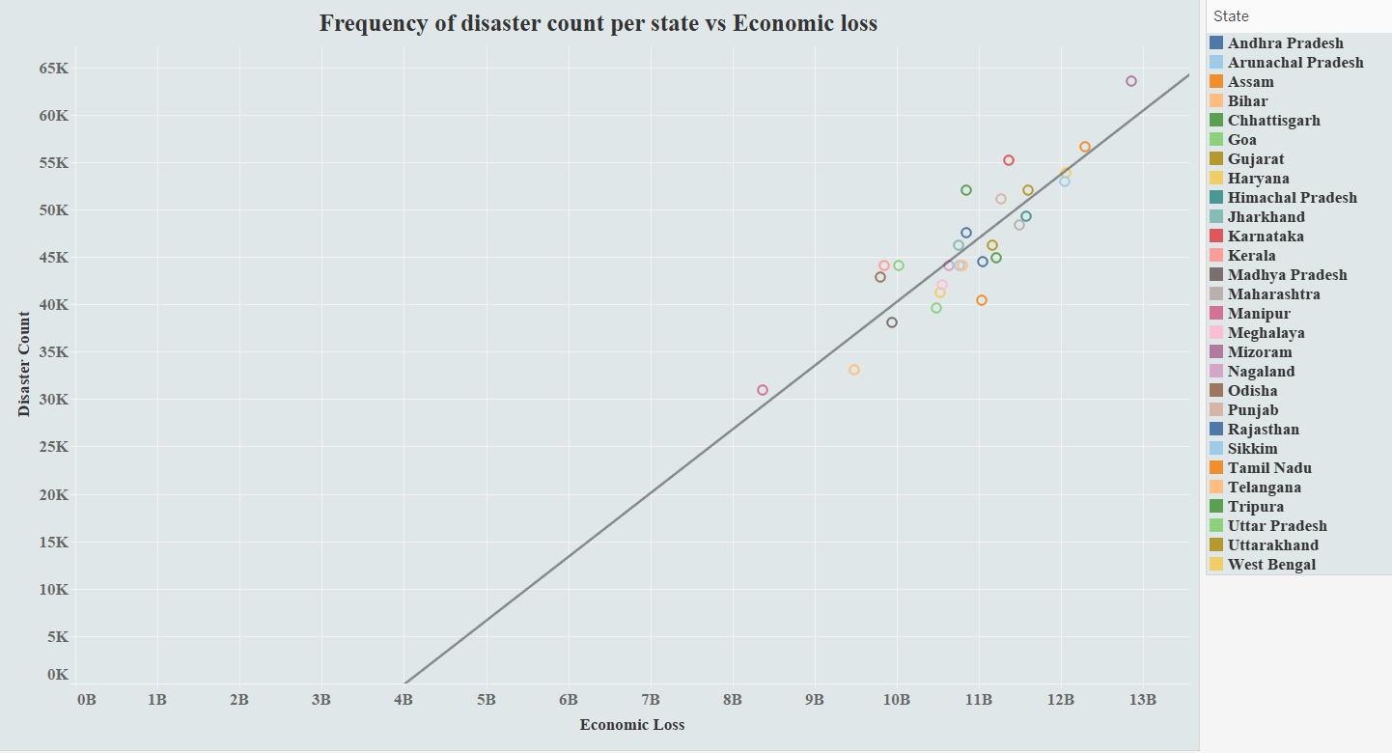

This visualization illustrates the relationship between the frequency of disasters and the resulting economic loss across various Indian states. Each point represents a state, with its position determined by the number of disaster events (y-axis) and the corresponding economic impact (x-axis). A positive correlation is observed, indicating that states experiencing a higher frequency of disasters tend to incur greater economic losses. The trend line reinforces this direct relationship, suggesting that disaster frequency is a significant driver of economic damage at the state level. This analysis helps identify the regions most vulnerable to both frequent disaster events and substantial financial impacts.

**CHART – 3**

**Count of disasters per disaster type**

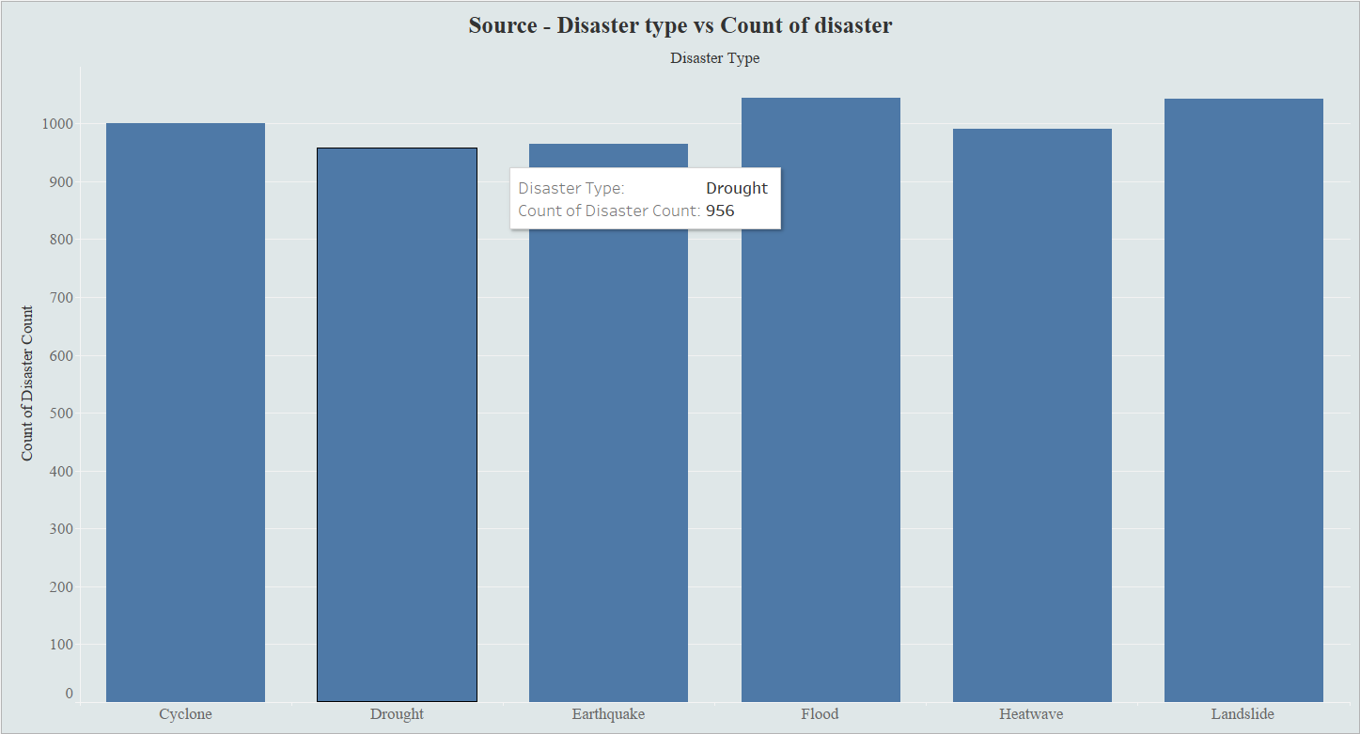

This chart – 3 illustrates the count of disasters categorized by disaster type, highlighting the frequency of events such as Cyclones, Droughts, Earthquakes, Floods, Heatwaves, and Landslides. This visualization is linked to the chart – 4 through interactive filtering actions. Upon selecting a specific disaster type from the chart - 3, the chart - 4 dynamically displays the corresponding economic loss segmented by infrastructure damage severity levels (Low and Moderate). This setup enables a focused analysis of the economic impact and infrastructure vulnerability associated with each type of disaster.

**CHART – 4**

**Economic loss per disaster type segmented by infrastructure damage severity**

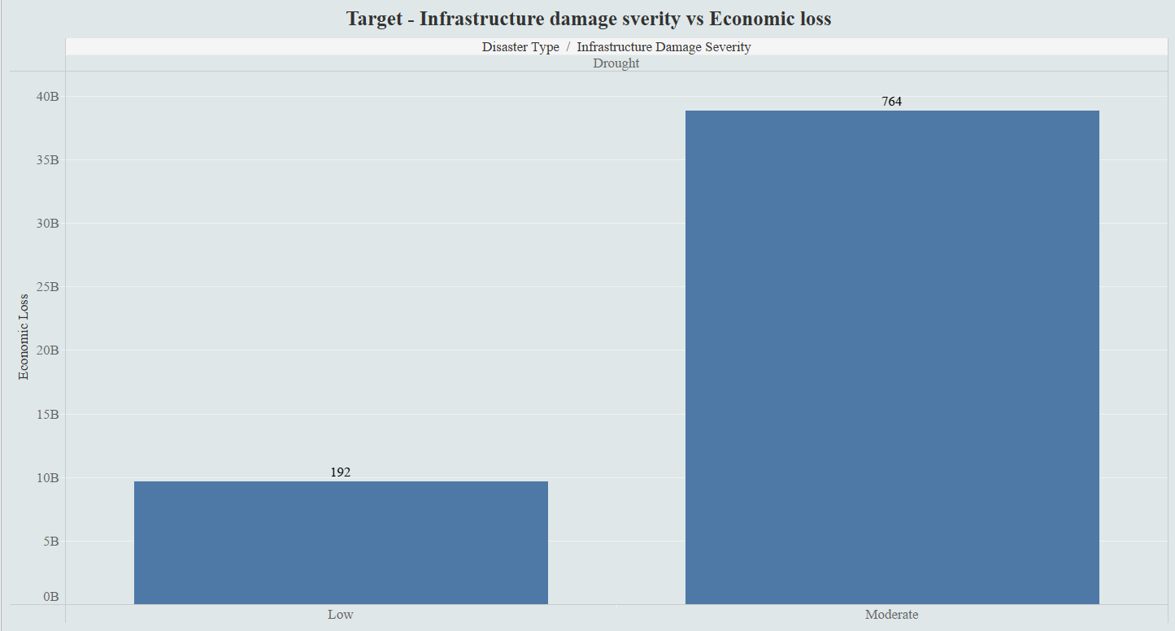

This chart illustrates the economic loss segmented by infrastructure damage severity for the selected disaster type. It categorizes the financial impact into "Low" and "Moderate" severity levels. The chart shows that moderate infrastructure damage accounts for a significantly higher economic loss compared to low severity, indicating that as the severity of damage increases, the associated financial burden rises substantially. This view helps in understanding the proportional relationship between infrastructure vulnerability and disaster-induced economic losses.

**CHART – 5**

**Count of affected population per state**

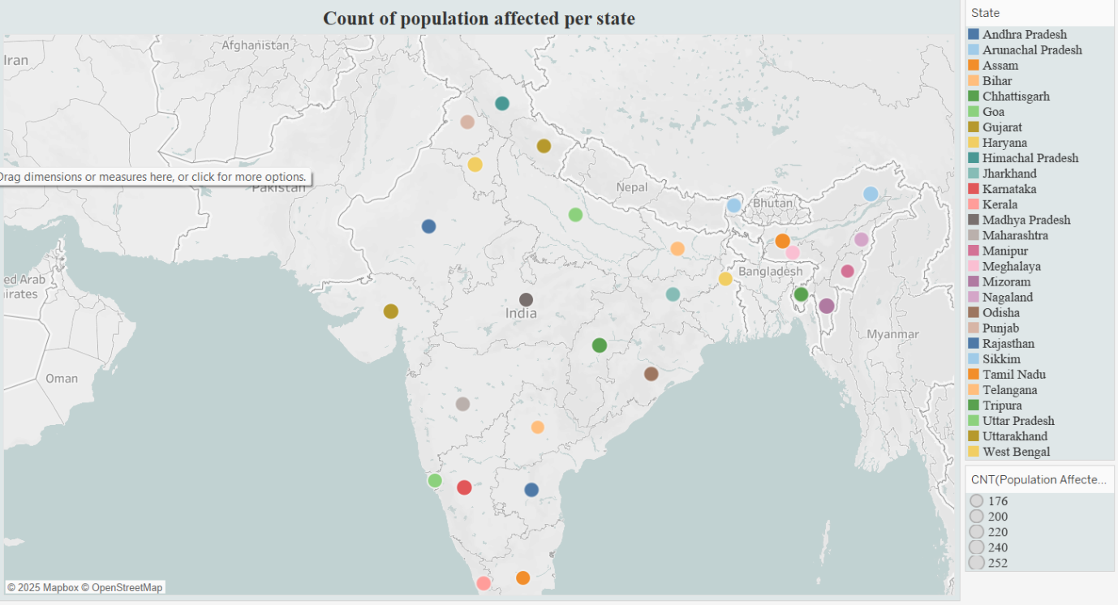

The map visualizes the count of population affected by disasters across different states in India. Each colored circle represents a state, with its size corresponding to the number of people impacted. States with larger markers have experienced a higher count of affected populations, highlighting the regions most vulnerable to disasters. Additionally, this map is enhanced with interactivity — clicking on any state redirects the user to the corresponding disaster information on Wikipedia, enabling quick access to detailed context. This interactive feature supports a deeper understanding of disaster impact patterns and facilitates rapid information retrieval for specific states.

**CHART – 6**

**Fatalities per disaster type**

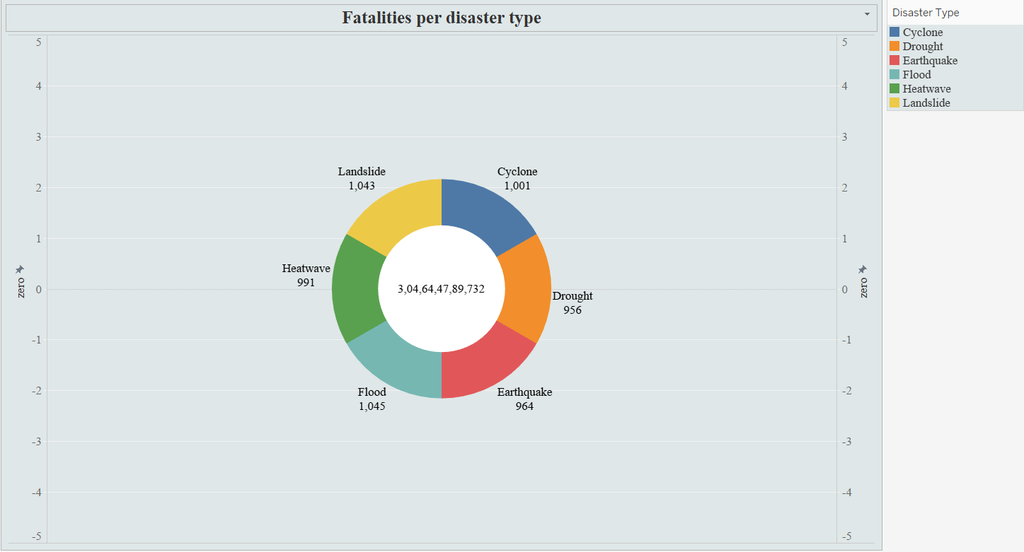

The chart illustrates fatalities per disaster type, while the figure displayed at the center (3,04,64,47,89,732) represents the total economic loss, not the total fatalities. Among the disaster types, floods (1,045 fatalities) and landslides (1,043 fatalities) caused the highest number of deaths. Cyclones (1,001 fatalities), heatwaves (991 fatalities), earthquakes (964 fatalities), and droughts (956 fatalities) followed closely, showing that fatalities are relatively evenly distributed across the different disaster types, with only slight variations. Despite this balance in fatality numbers, the massive economic loss highlights the severe financial impact of these disasters.

**DASHBOARD**

**Disaster Analysis in India**

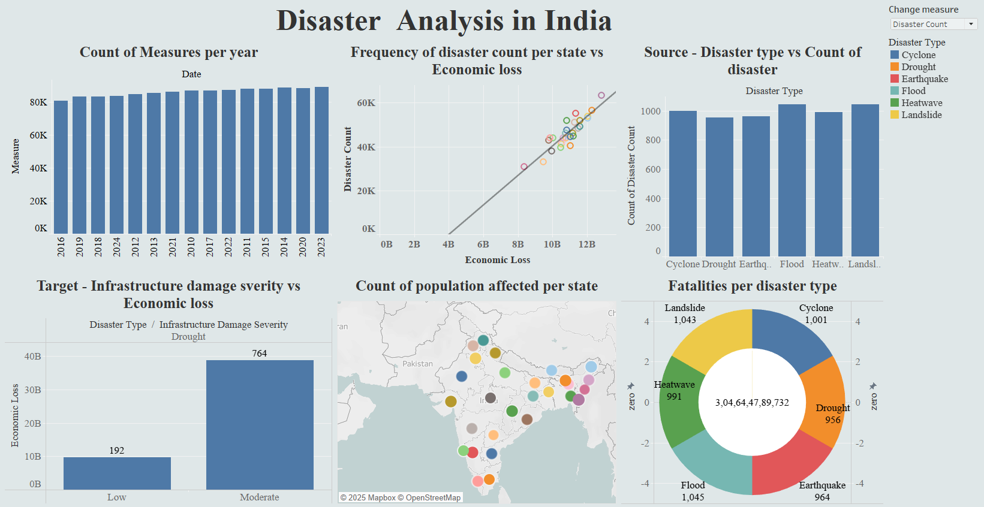

The dashboard shows an increasing trend in disaster management measures over the years. States with higher disaster counts experience greater economic losses. Floods and landslides are the most frequent and deadliest disaster types. Total economic loss due to disasters is extremely high. Moderate severity droughts cause much higher economic damage compared to low severity ones. Many states across India have been significantly affected in terms of population. Overall, the analysis highlights the urgent need for stronger disaster mitigation strategies.

**CONCLUSION**

This project offers a analysis of disaster trends and their impacts across India, using a variety of visualizations and datasets. The study highlights that floods and landslides are not only the most frequent disaster types but also lead to the highest number of fatalities. Droughts, although less deadly in terms of immediate fatalities, cause massive economic losses, especially when infrastructure damage is classified as moderately severe. The steady rise in disaster management measures over the years reflects an increased governmental and societal focus on preparedness and response efforts.

The overall economic loss figure underlines the urgent need for strategic investment in disaster resilience, infrastructure strengthening, and early warning systems. This analysis emphasizes that while response measures have improved, a stronger focus on proactive risk reduction, sustainable planning, and climate adaptation strategies is essential to minimize future losses. Through targeted interventions, policy reforms, and community awareness programs, India can move towards more resilient disaster management practices, safeguarding both lives and economic assets.